*1.Try to Define Business Problem and Metrics then Machine Learning Metrics*

**Business Problem:**

Significant Customer Complaints towards low performances of Conventional Smoke Detector in detect the true fire trigger Sales softening trend for Months.

**Business Metrics:**

Customer Satisfaction Survey Score towards performances of Smoke Detector Product

**AI Solution:**

AI based Smoke Detector

**Machine Learning Metrics**

F1 Score of AI based Smoke Detector

*2. Try Data pipelines , Especially definition; Validation;Defense;Splitting; and Serialization*

**Data Collection:**

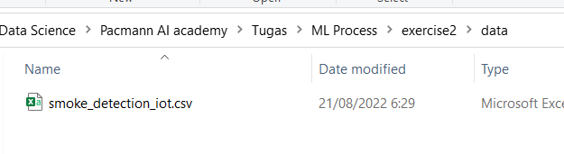

**Data Definition:**

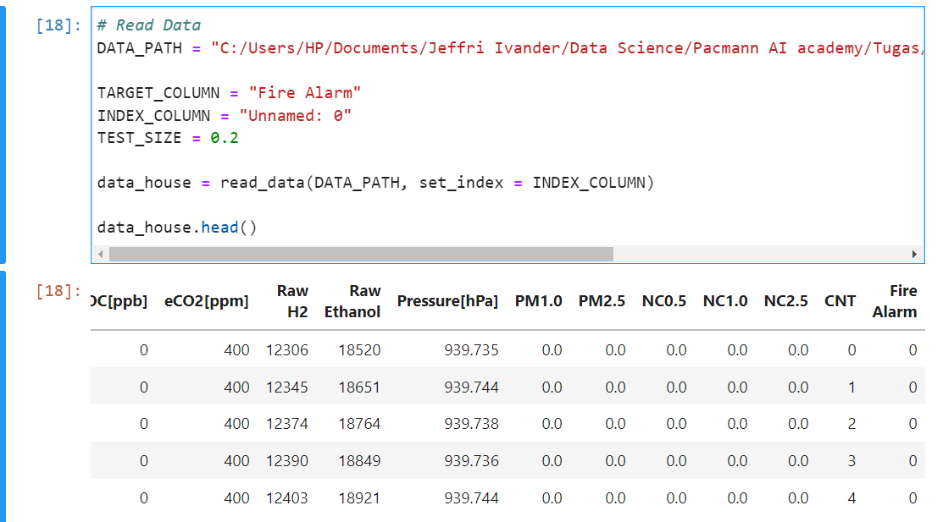

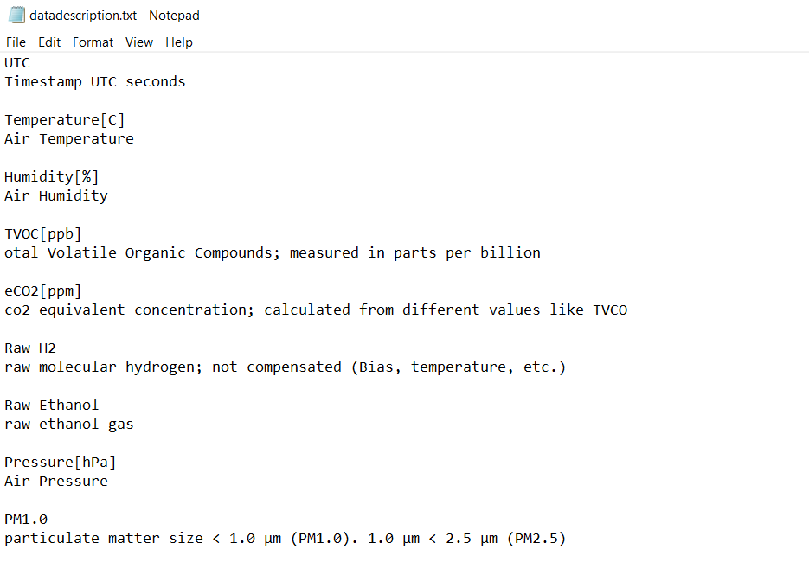

**Data Validation**

All data is valid and No Null identified

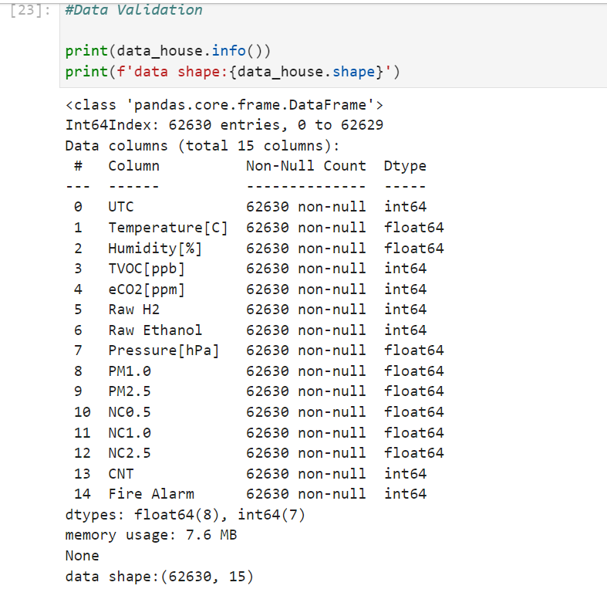

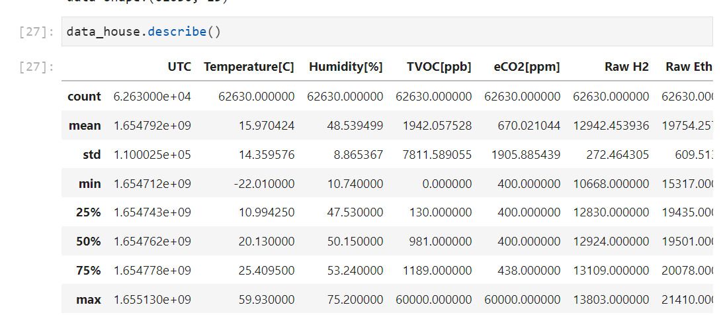

**Data Defense**

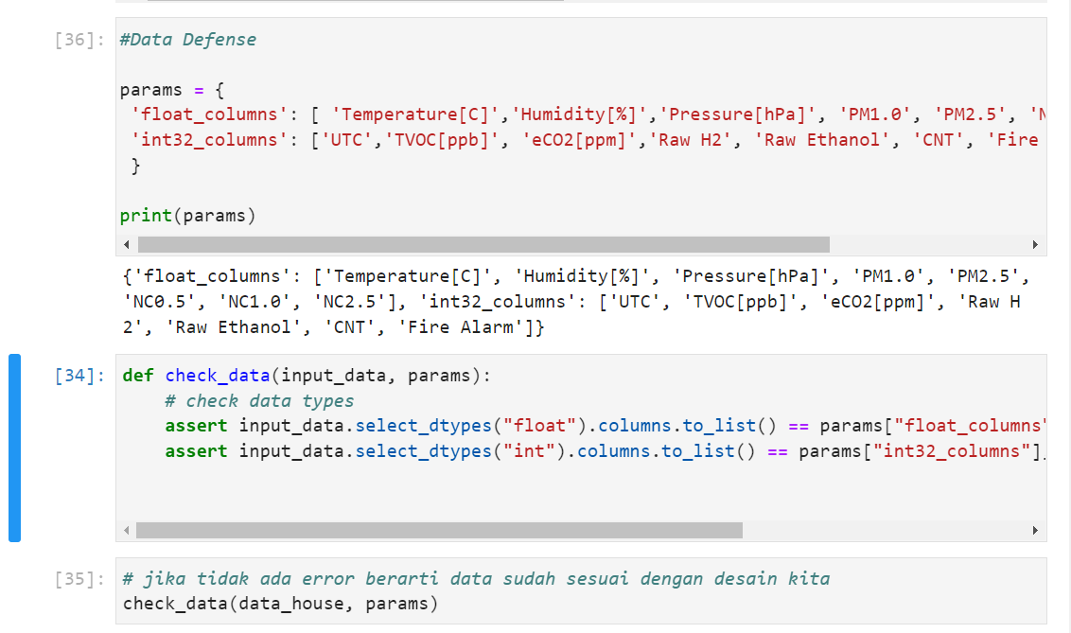

**Data Splitting and Data Serialization**

